LAB – 1 FORMING NETWORK CONNECTION BETWEEN TWO PC
IP CONFIGURATION OF SYSTEM 1:
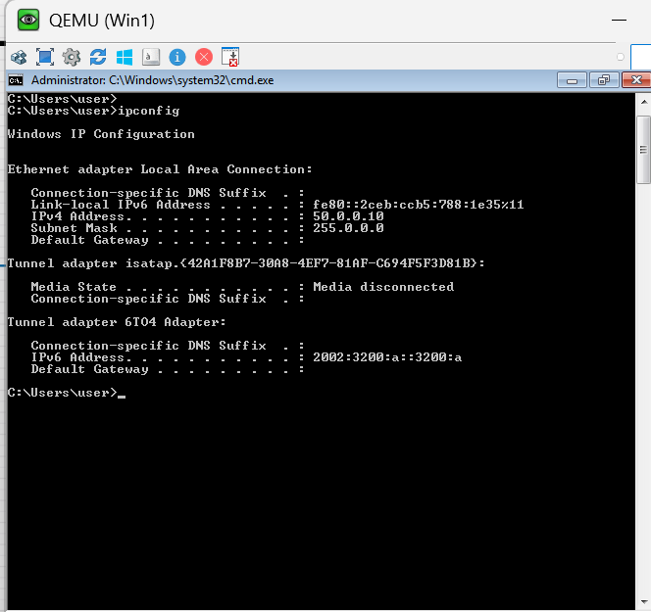
IP CONFIGURATION OF SYSTEM 2:
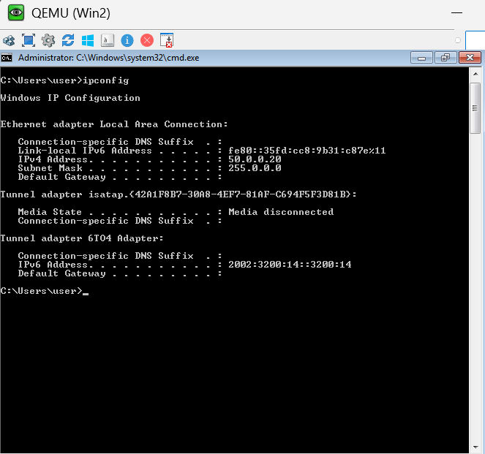
CHECKING NETWORK REACHABILITY: TARGET IP(50.0.0.20)
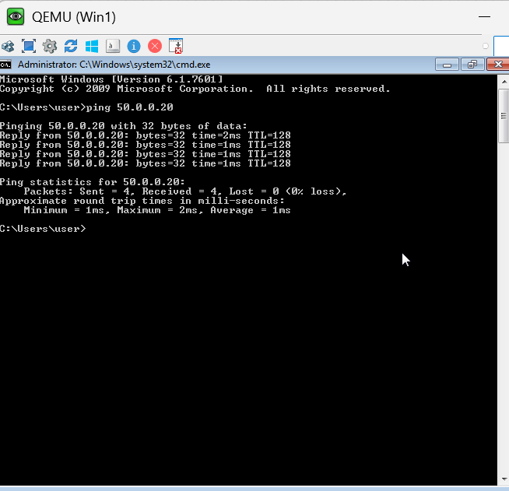
CHECKING NETWORK REACHABILITY: TARGET IP(50.0.0.10)
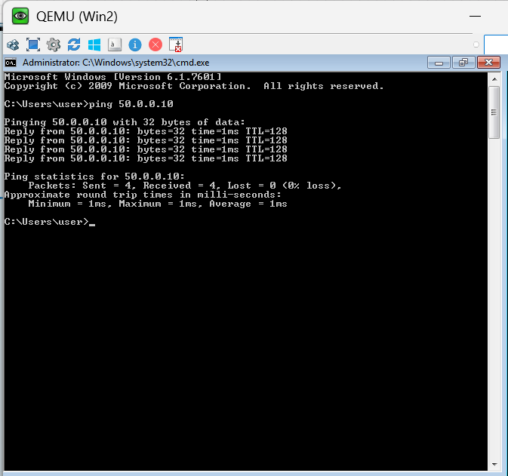

NETBIOS:
CHECKING NETWORK REACHABILITY USING SYSTEM NAMES
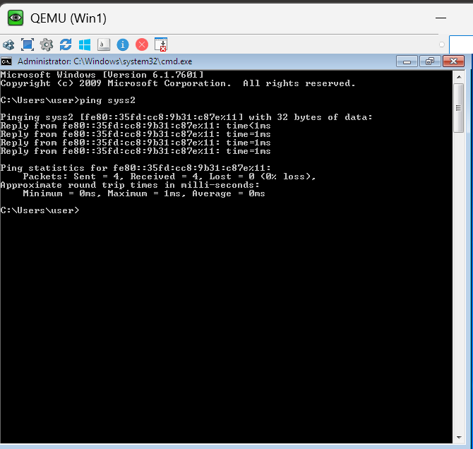

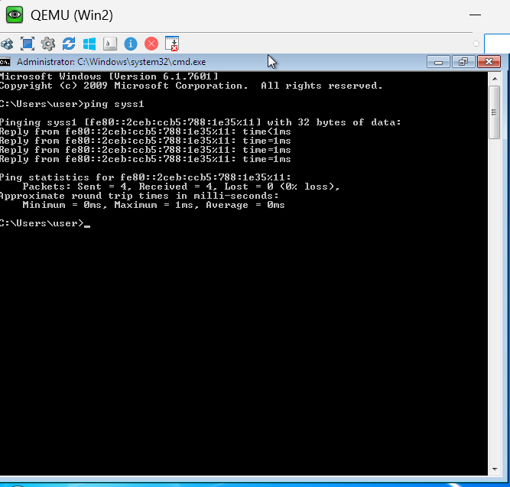

SHARING FILES USING NETWORK:
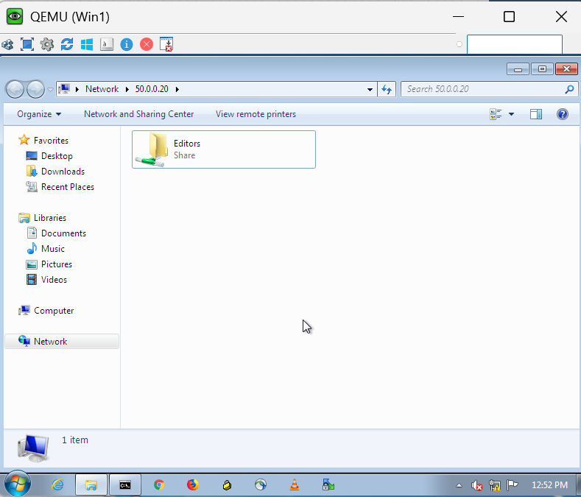

RDP- REMOTE DESKTOP PROTOCOL
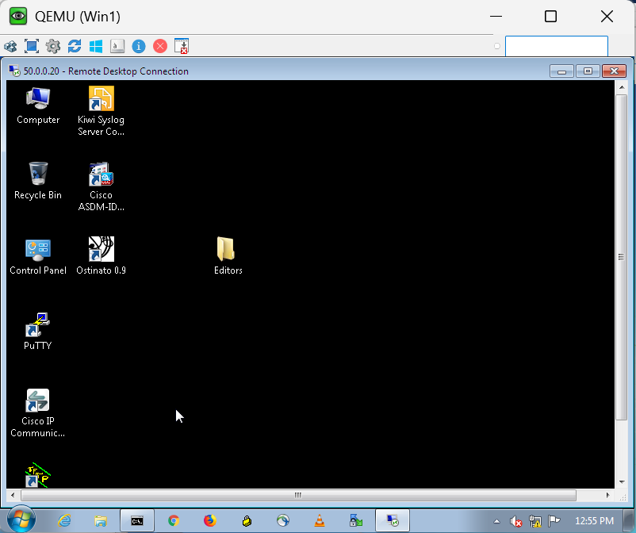
BAGAVATHI J

